CURRICULUM VITAE

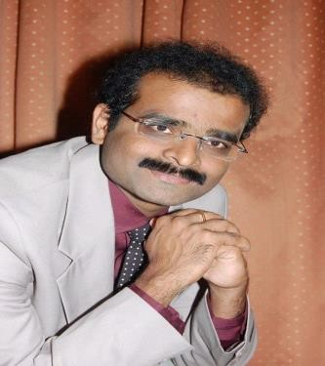

NAME **DR.SOMASEKHARA.N.R**

AGE 38 YEARS

SEX MALE

D.O.B 16/01/76

PERMANENT ADDRESS Dr.Somasekhara.N.R. 9 th ward, Door no. 89 Netaji Cirle road, Behind new masque Bagepally-561207 Chickkaballapur district Karnataka

E-mail : [d_reddy1976@rediffmail.com](mailto:d_reddy1976@rediffmail.com)

Mobile**: 9148494361**

EDUCATION QUALIFICATION

DEGREE UNIVERSITY INSTITUTION YEAR OF COMPLETION

B.D.S. KUVEMPU SJM DENTAL 1999 SEP UNIVERSITY COLLEGE &

HOSPITAL, CHITRADURGA, KARNATAKA

M.Sc. (Epidemiology) THE. TN. MGR DEPARTMENT OF 2009 MAR MEDICAL UNI- EPIDEMIOLOGY

VERSITY

PhD (Epidemiology) M.I.D.S Doctoral Thesis submitted &Health Economics)

Leadership and Management Programme, Institute of Global Health, INCLEN Trust

**WORKING EXPERIENCE**: ***A Total of 10 years, worked***

***as a faculty, both in Medical and Dental colleges of India.***

|  |  |  |
| --- | --- | --- |
| ***Medical Officer*** | ***Star Health and Allied Health Insurance Company*** | ***2008*** |
| ***Senior Manager*** | ***Star Health and Allied Insurance, corporate office***  **(Tangens )** | ***2014*** |
| **Regional In-charge, Karnataka** | **GRIP ORTHO Orthopedic Implant Company** | **2017** |
| **Consultant** | **Yogeshwar Orthopedic Implant Company** | **2018** |
| **Business Development Manager: For Karnataka** | **Sharma Orthopedics Company** | ***2020*** |
| **Zonal Manager- South Zone** | **Green Ortho Surgicals, Orthopedic Implant Company** | ***2022*** |
| ***State Business Head, Karnataka*** | ***Nebula Surgicals, Orthopedic Implants*** | ***2023*** |
| ***General Manager- South Zone*** | ***Sofia Surgicals*** | ***2024*** |
| ***Vice President, and Country Manager- Pan India*** | ***Ved Orthopedics International*** | ***2025*** |
| ***Total Corporate Experience*** | | ***16 years*** |

LANGUAGES KNOWN: ENGLISH (IELTS SCORE 7/10) HINDI (GRADUATE LEVEL) RUSSIAN (CERTIFICATE LEVEL)

M.S. UNIV. BARODA

KANNADA (READ, WRITE, SPEAK)

TELUGU (READ, WRITE, SPEAK)

GUJARATI (READ, SPEAK) TAMIL (SPEAK)